Instructions for Medical Data Labeling

# **Description**

A brief manual on how to label your data and generate target masks for the medical segmentation task using deep learning.

# **Disclaimer**

These instructions are based on my recent personal experience and findings. I found them useful for my task. However, there might still be better ways to accomplish this task.

# **Task**

My task was to segment the lung section in 3D CT volumes. Although most of my labeling task is for that, still these instructions can be applied to other segmentation tasks or for other parts as well.

# **Data**

My data consisted of CT scan volumes of various patients. I had 150 volumes for training, 20 volumes for validation purposes, and some for predictions.

# **Data Labeling**

Data labeling for the segmentation task means generating masks for your dataset which you can later use for training a deep neural network. There are different tools available for medical data labeling. I think the most prominent and useful ones for CT data are

1. Slicer
2. ITK-SNAP

In my case, I used 3D Slicer. It is easy to use. You can also choose ITK-SNAP if you like.

**Segmentation Types**

I think we can categorize segmentation methods (label masks) into three categories i.e. manual, semi-automatic, and fully automated.

**Manual Segmentation –** Manual segmentation refers to when you label each volume manually. In fact, not only each label, you have to label each slice manually. As you might have guessed already, such a process can have two main limitations.

1. Labeling the data in this way can take forever. For example, in my case, I have 150 training and 20 validation volumes, and each volume contains more than 1000 slices in all three directions. To manually paint and mask all these slices for 150 volumes can take almost forever.
2. The second issue is related to the domain expertise required to annotate the medical data. Since I am not a medical expert, I cannot label the data as well as a medical expert. Hiring an expert is costly and not feasible in most cases.

**Semi-automatic Segmentation –** These limitations bring us to semi-automated methods. Using these methods, we can label all slices at once. However, we still need to manually adjust masks in each slice because these methods are not completely accurate. In 3D Slicer, some methods are Grow from seeds, Fast Marching, Fill between slices, and Threshold.

**Fully-automated Segmentation –** Luckily, Nvidia released AI-Assisted Annotation Tool (Nvidia AIAA) which is useful for medical rookies like me. This tool is designed with the help of many experts and it employs deep learning to generate masks. This tool is available inside 3D Slicer as an extension. You can go to extensions in 3D Slicer and then add the Nvidia AIAA extension. You can choose ‘Auto-segmentation’ or ‘Segment from boundary points’. However, this tool might not work for all kinds of segmentations. It only provides functionality for Brain MRI segmentation, CT lung segmentation, and few more cases. In my case, I was able to use the provided CT lung segmentation model since that is what I needed. I will share the details of the process in the coming sections.

Refer to the link<https://developer.nvidia.com/blog/annotation-transfer-learning-clara-train/> for more details on this.

# **Lung Segmentation in 3D Slicer**

There are various ways to segment regions (lung in my case) in an automatic or semi-automatic manner within 3D Slicer. I will share some of these methods based on my experimentation. Note that there can be more ways as well besides the ones that I am going to mention.

# **Labeling via Nvidia AIAA**

One of the most convenient and useful methods which I used for my purpose, is using the Nvidia AIAA tool within 3D Slicer. It helped me to speed up the labeling process. I was able to label my data in two days, which could have taken several days or months without the Nvidia tool.

**Steps**

1. Open 3D Slicer and install the Nvidia AIAA extension. You can do this by opening **Extension** **Manager** from the toolbar at the top. Then click on **Install Extensions** and search for the Nvidia AIAA tool. Click on **Install** after finding it. You might have to restart the 3D Slicer after installing the extension.
2. After that, load your DICOM or Nifti image into the 3D Slicer
3. After that, click on the **Modules** dropdown of the toolbar at the top of the 3D Slicer and select **Segment Editor** from the menu.

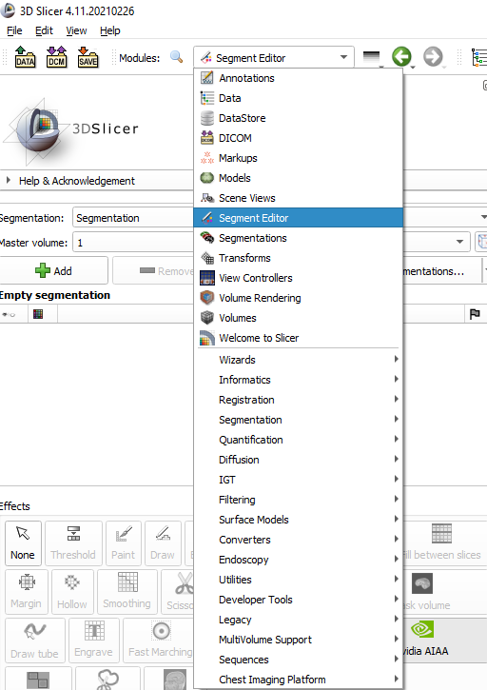

1. In the Segment Editor, you can see a bunch of **Effects.** Chose the Nvidia AIAA tool from there.

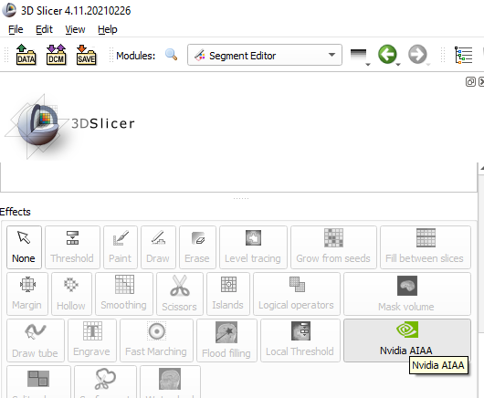

1. Next, go to the **Auto-segmentation** and chose the model. For the lung case, choose the lung segmentation model as shown in the figure below.

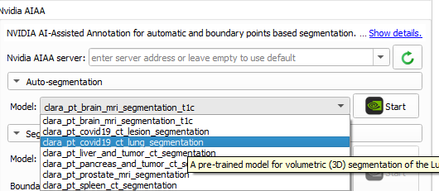

1. After that click on **Start** and wait for the process to complete. It will take few seconds to one minute.
2. After that, you can see the segmentation results in 3D Slicer. You can also click on **Show 3D** in the Segment Editor to visualize the segmentation in 3D.

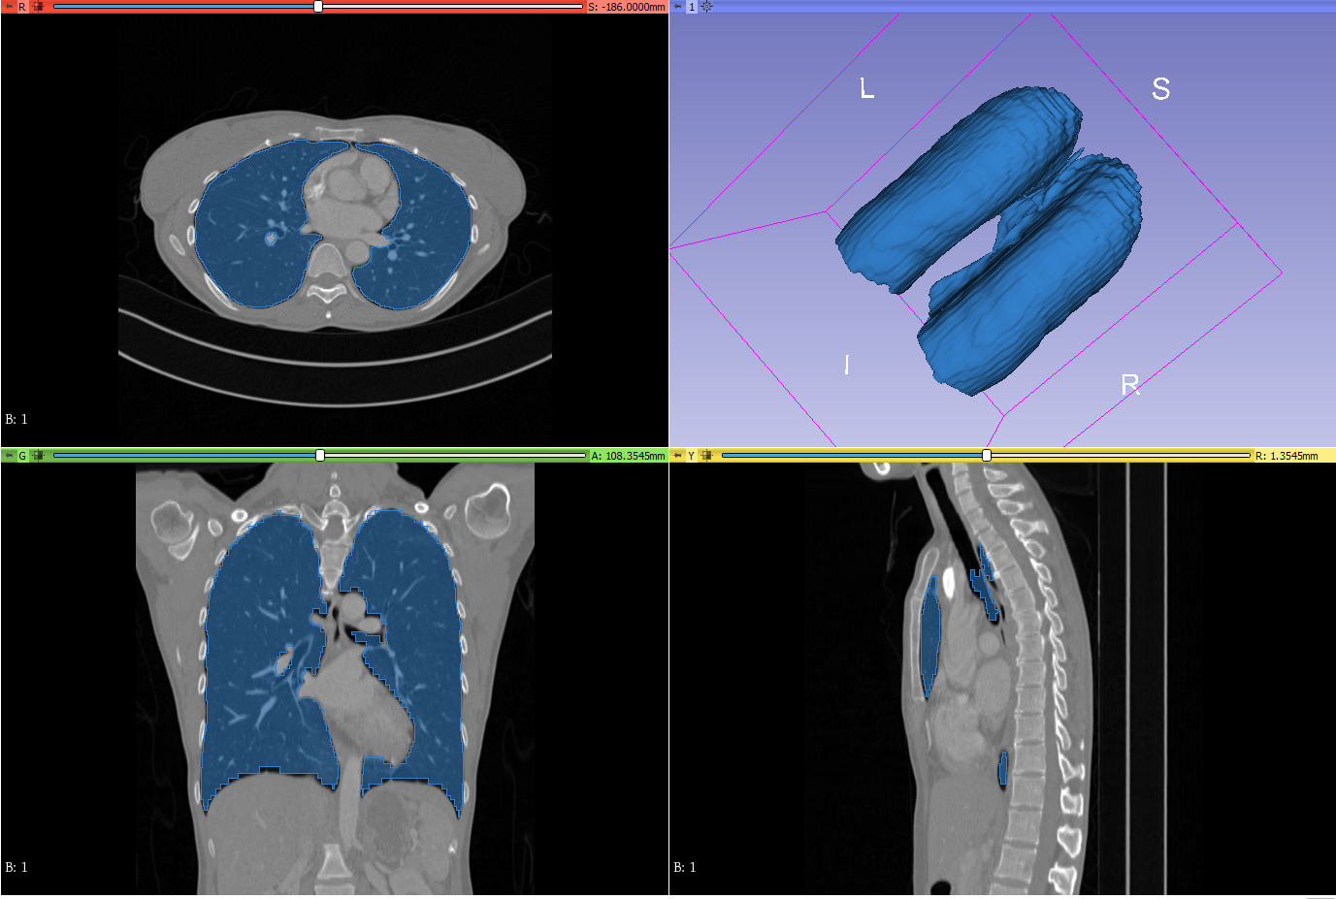

1. After that go to the **Segmentations** section from the **Modules** dropdown. Scroll down and click on **Export**.
2. Go to **File** on the top left corner and select **Save**. A box will appear. Select the file with **‘label.nrrd’** at the end e.g. ‘Segmentation-lung-label.nrrd’. Change the extension to the one you want. I used the .nii format, which is the same as my data. Set the path and then save the label mask.

# **Labeling via Fast Marching effect**

Later I tried looking for some more labeling methods. The first one that I found is Fast Marching algorithm. It is available in 3D Slicer as part of **SlicerSegmentEditorExtraEffects** extension.

**Steps**

1. Install the **SlicerSegmentEditorExtraEffects** extension from the **Extensions Manager.**
2. Load your image data and go to the **Segment Editor**
3. Here click on the **Add** option. This will create a new **Segment**. You can modify the name and color of this segment.

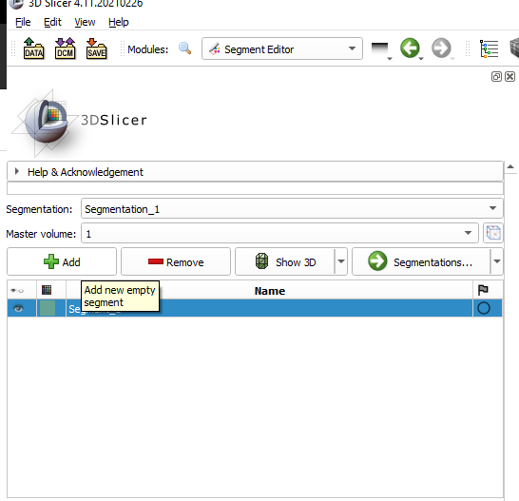

1. Select **Paint** from the **Effects** and paint lines at the region which you want to segment in both Axial and Coronal views. In my case, it is the lung region.

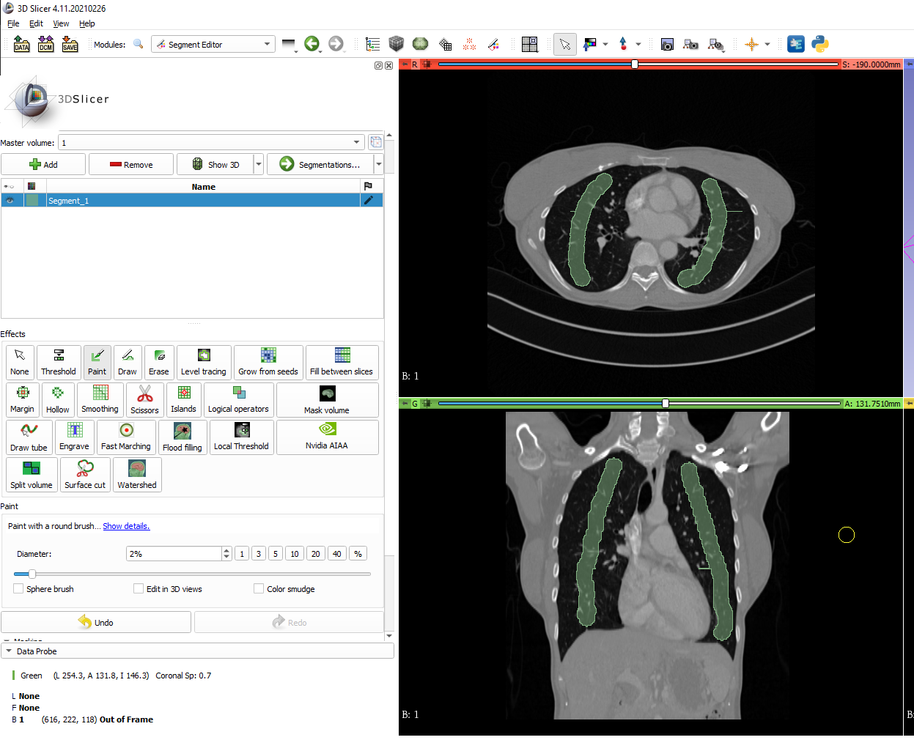

1. After that click on **Fast Marching** in the **Effects**, set the Maximum and Segment Volume (or leave it as it is), and click on **Initialize**. Results will be displayed in 5-10 seconds.
2. Visualize the results. You can also see results in 3D by clicking **Show 3D**. Play around with Maximum and Segment Volume if you want and click **Apply** when you are satisfied with the results.
3. Export and save the label mask as described in the previous method.
4. This method can be used to segment other parts or multiple parts (by creating new segments for each part) as well.

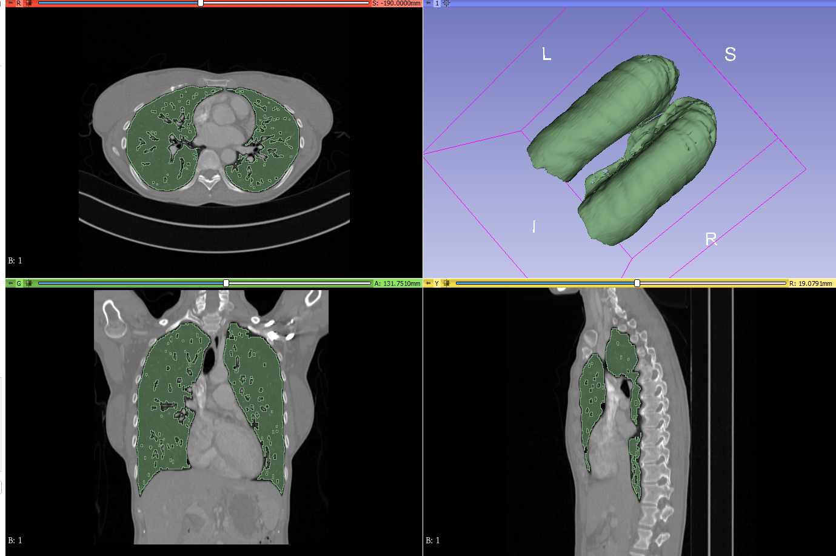

# **Labeling with Grow from seeds effect**

One of the most convenient and useful methods which I used for my purpose, is using the Nvidia AIAA tool within 3D Slicer. It helped me to speed up the labeling process. I was able to label my data in two days, which could have taken several days or months without the Nvidia tool.

**Steps**

1. Load the image, go to **Segment Editor** and add a new segment.
2. Then click on **Threshold** in the effects. Set the threshold range. For empty or darker regions, keep the lower threshold fixed and change the higher one until you see visible separation. Do the opposite if you want to segment brighter regions like bones. For my case, I used -1024 to -500. After that click on **Use for masking**.

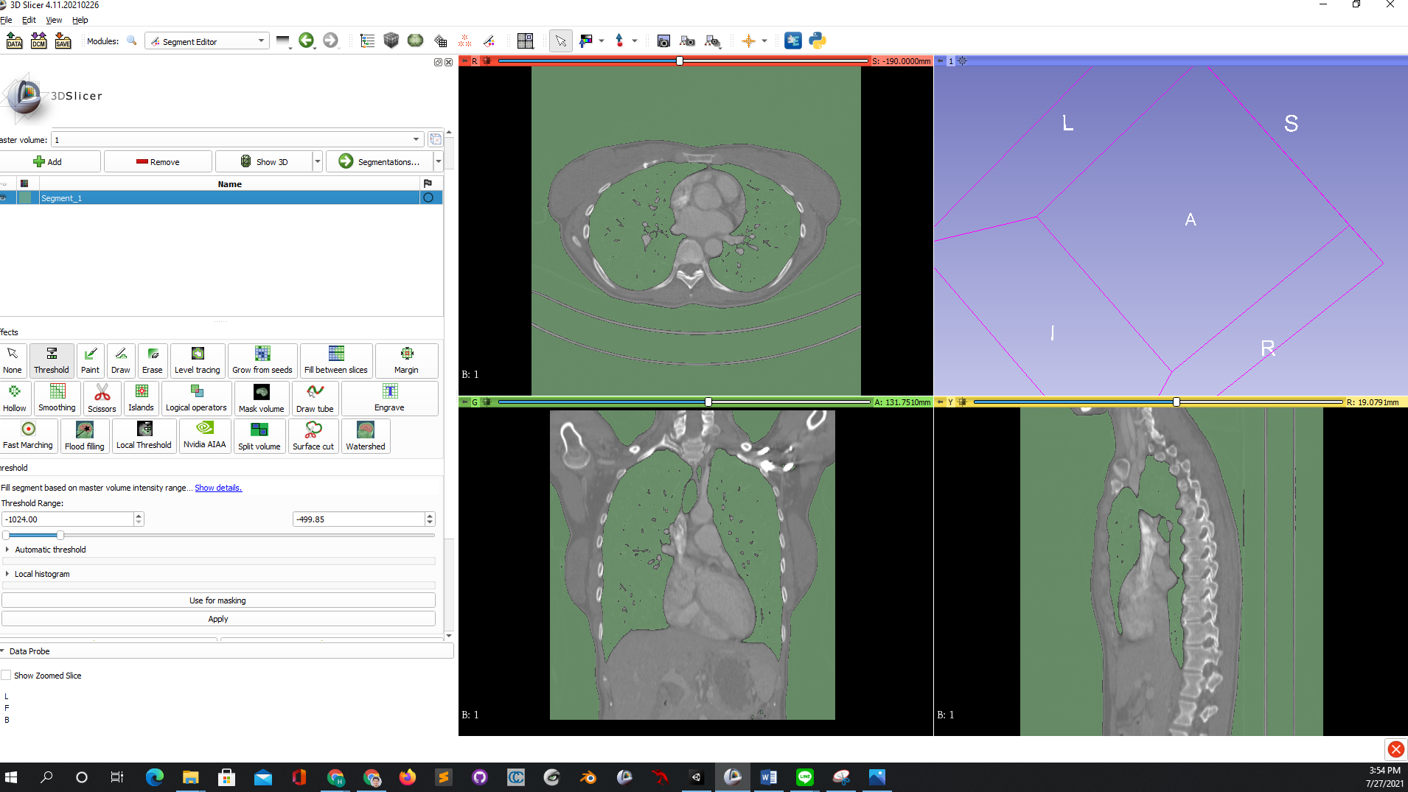

1. Then select **Paint** and draw lines in the desired regions like in the last method (Step 4).
2. Then add a new segment by click **Add**. After that click on **Grow from seeds** in the **Effects**. Then click on **Initialize** and wait for the results. Then click on **Apply**.
3. After that, you can visualize the results. Delete the new segment that you added in the end.

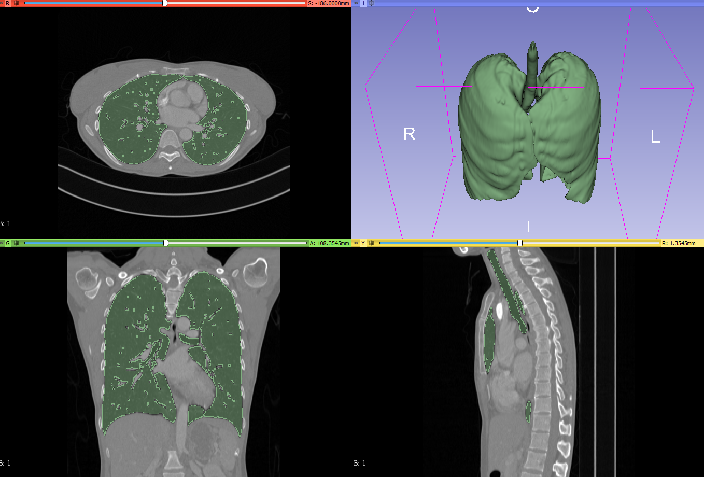

1. Export and save the mask.
2. This method can be used to segment other parts or multiple parts (by creating new segments for each part) as well.

# **Labeling with Thresholding**

We can also use simple thresholding to generate masks. However, this method might not work for every part of the body.

**Steps**

1. Load an image, go to **Segment Editor** and add a new segment.
2. Choose **Threshold** from **Effects** and set the desired limit until the separation is visible. For my case, I use a range of -1024 to -500. Then click **Apply.**
3. Now click on **Islands** in the **Effects**. Choose **Keep selected island** and then click on the desired region in one of the views. I clicked on one of the lung regions in Coronal view.

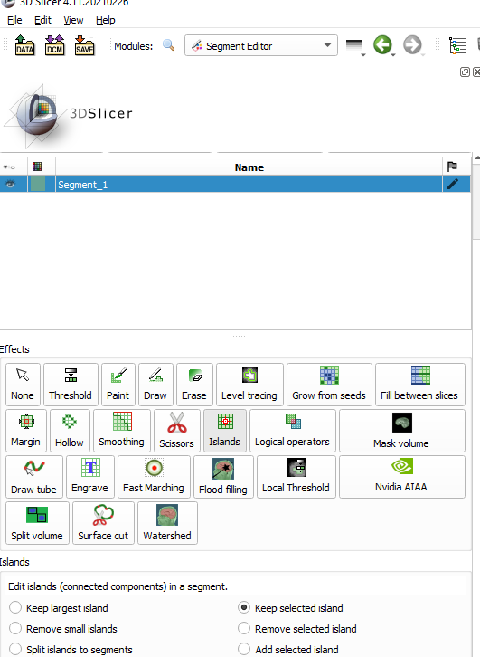

1. Visualize the results, export, and save the mask.

